SQL Query Validation for KPIs:
- Average Patient Stay Duration:
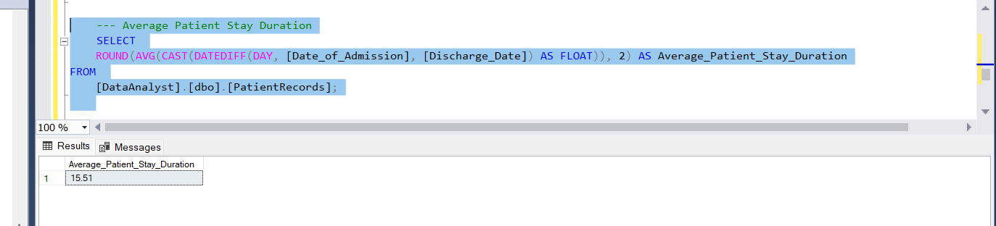
- Total Admission:
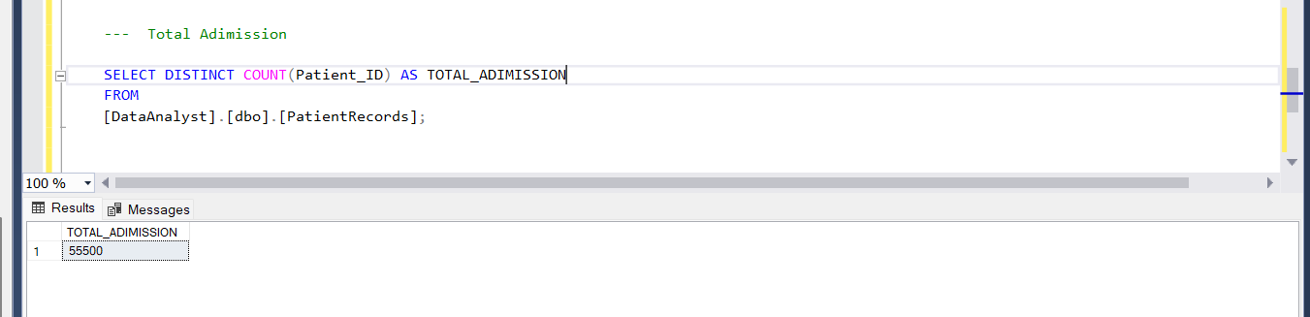

- Gross Revenue:
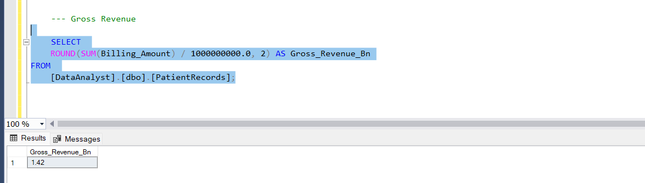

Chart Requirement:
I want to use charts to better understand our healthcare data. Here’s what we need:
- Yearly Revenue Trend:
A bar chart showing how much revenue we made each year.
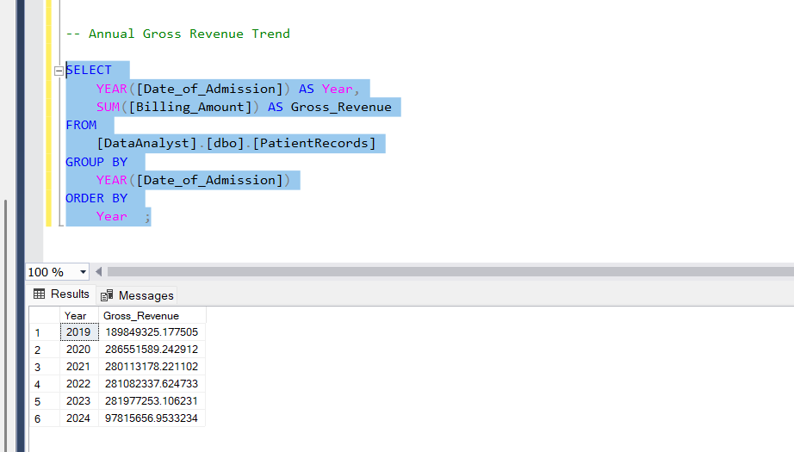

- Revenue by Insurance and Hospital:
A chart comparing revenue from different insurance providers and hospitals.
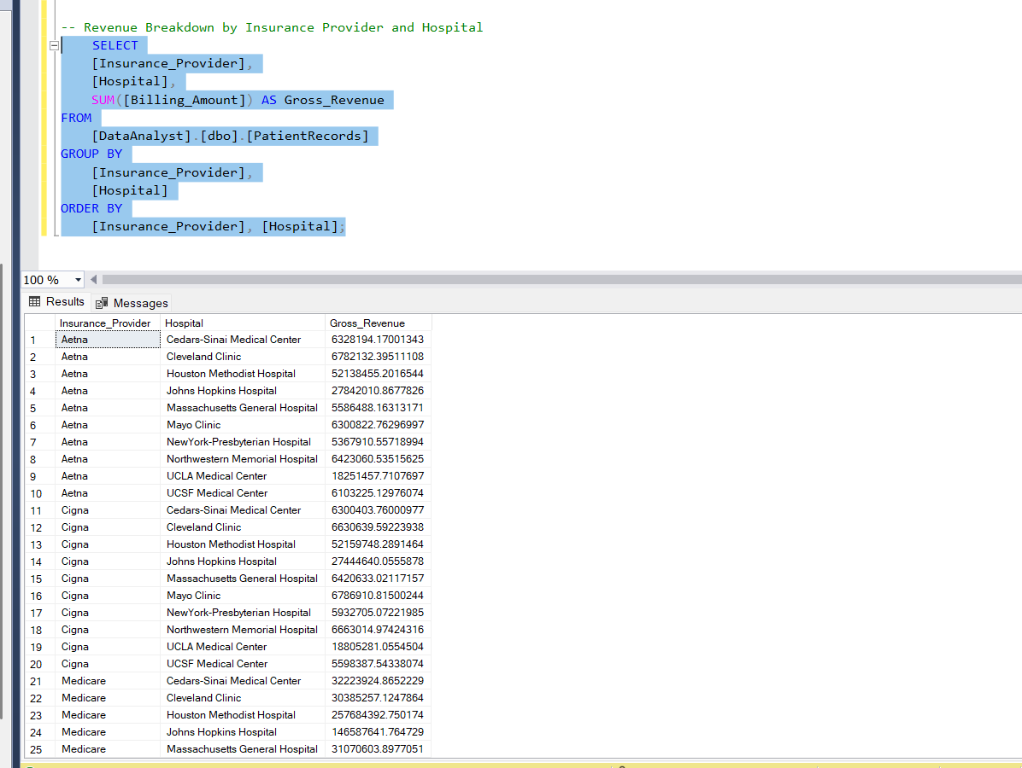

- Hospital Locations:
A map showing where our hospitals are located.
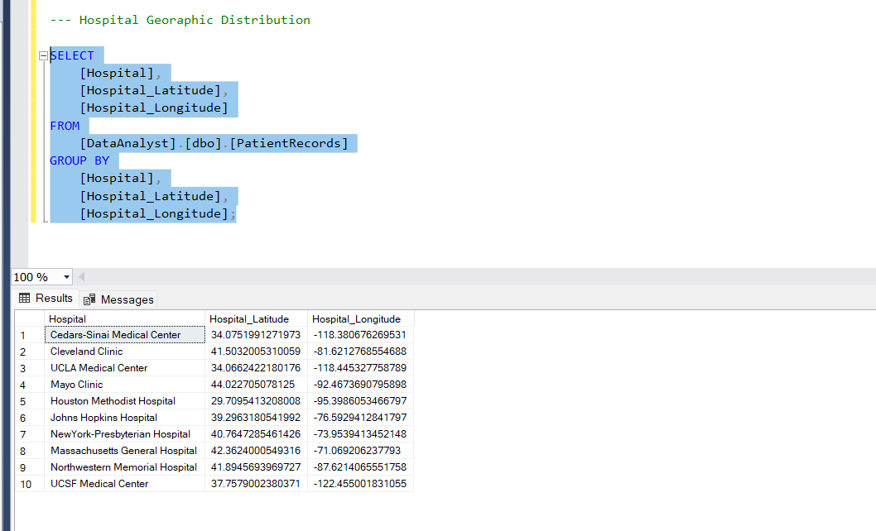

- Admissions by Blood Type and Gender:
A donut chart showing how many patients were admitted, grouped by blood type and gender.

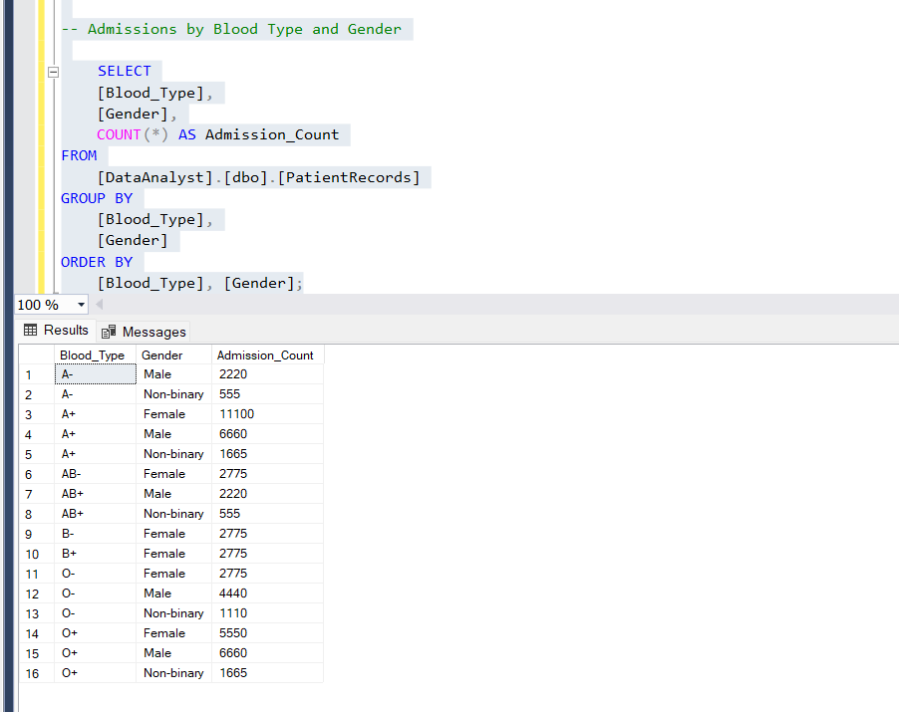

- Admissions by Medical Condition:
A summary of admissions by medical condition to highlight common health issues.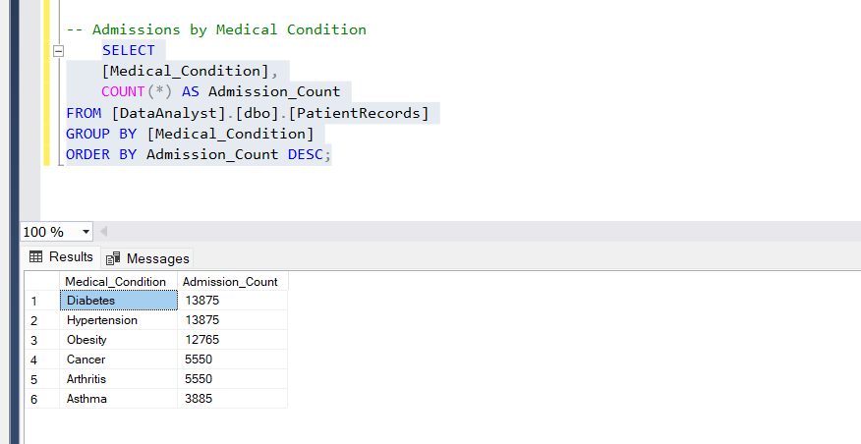

- Admissions Overtime:
A timeline of admissions to spot trends and patterns over time.
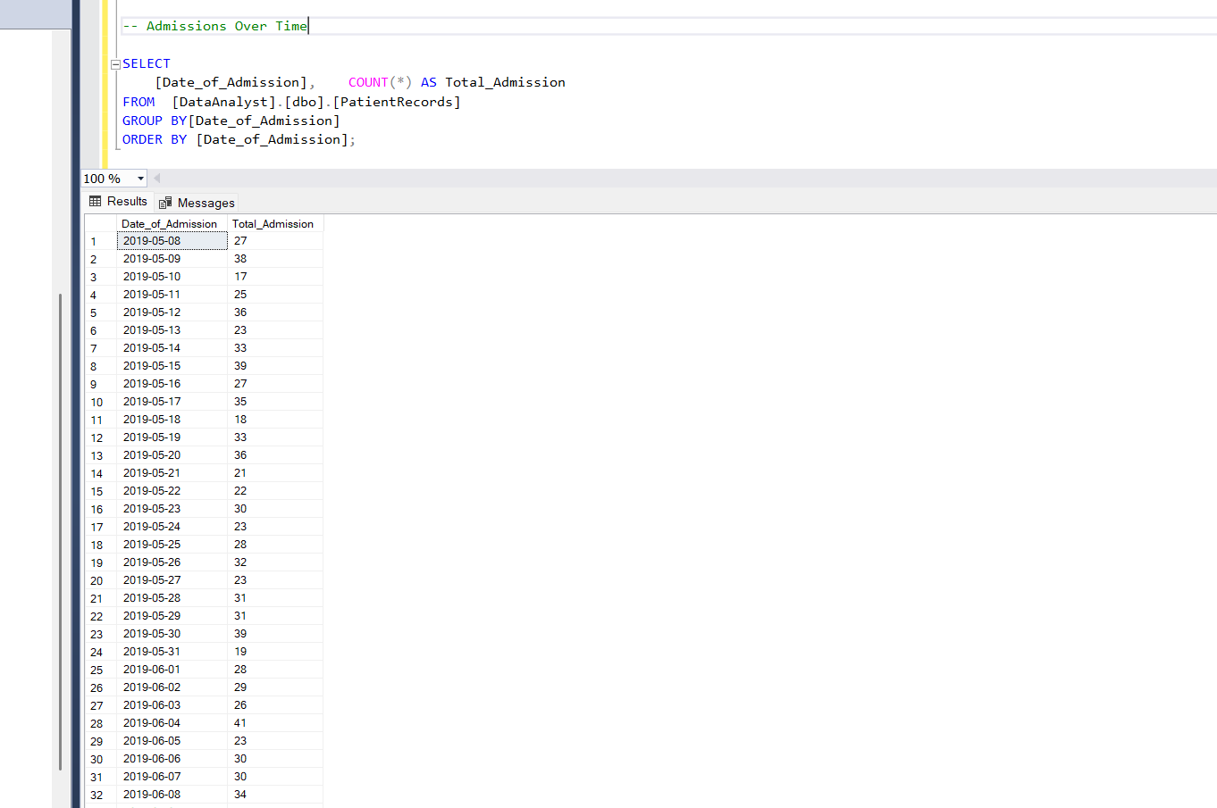

- Patients Summary Table:
A detailed table with key patient and operational metrics for easy review.

